GZ Birotor | 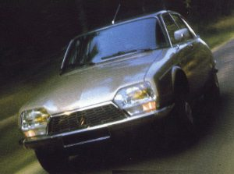
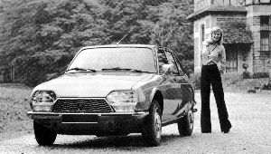 | 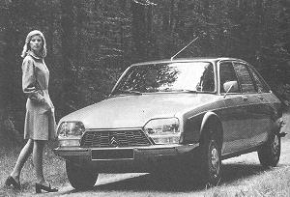
A total of 873 GZ Birotors were built between 1973 and 1975. Initial trials were undertaken using a NSU and then the M 35. NSU employed the Wankel engine in the stunning Ro 80 with Rolls Royce and Mazda also investigating the engine's possibilities. It was rumoured that the CX would be fitted with this engine - indeed surprise was expressed at the time that the Birotor was not fitted to a top of the range model but to the mid range GS .
Powered by a rotary engine invented by Felix Wankel and built by Comobil, later Comotor, a joint venture between Citroën and NSU, the car was not without its problems - high fuel consumption, high pollution, high oil consumption and lack of reliability all served to kill the project. NSU was absorbed by Audi and the Wankel engine was dropped by European motor manufacturers. Mazda in Japan persevered however and the RX series of sports cars still make use of the rotary engine.
How the Wankel rotary engine works
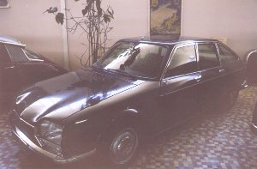 | 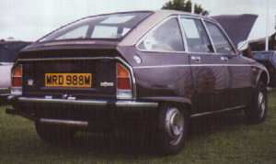
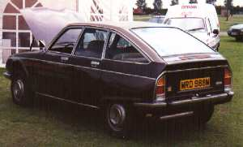 | 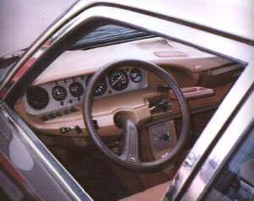
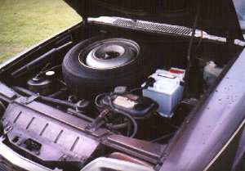 | 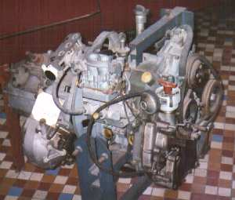

Engine | Twin chamber Wankel rotary, 1990 cc, 107 bhp DIN @ 6500 rpm, 11 CV French fiscal rating, water cooled, Bosch electronic ignition, twin choke Solex carburettor | 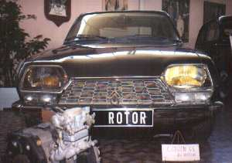
Transmission | Front wheel drive via 3 speed semi automatic gearbox
Steering | Rack and pinion
Brakes | Powered discs all round
Suspension | Hydropneumatic , self levelling, independent featuring anti dive/anti squat geometry | 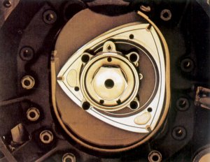
Tyres | Michelin XAS 165 HR 14
Bodywork | Modified GS saloon with flared wheel arches
Dimensions | Length : 4.12 m, width : 1.64 m
Fuel consumption | 13 litres per 100 km | 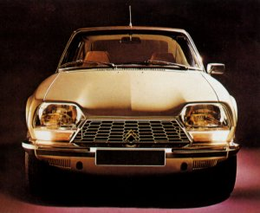
Top speed | 175 kph
Fuel tank capacity | 56 litres

